1 SUBMISSION OF THE MANUSCRIPT
In order to publish a manuscript in the Geotechnical Mechanics journal, the following information should be submitted:
- manuscript ( MS Word, file type *.doc or *.docx);
- abstract, references and information about the authors;
- license to publish, signed by the authors.

2 STRUCTURE OF THE MANUSCRIPT
The volume of the article (including tables and figures) should not exceed:
- 15 pages (reference list should contain at least 20 references) for review articles;
- 12 pages (reference list should contain at least 10 references) for experimental and theoretical articles.

2.1 Structure of a manuscript
Title of a manuscript
Last name and first name of the author(s)
Affiliations of the author(s)
Abstract and keywords
Text of a manuscript (the main body of text portion)
References
About the authors

An example of a manuscript’s structure is presented in Appendix A.

2.2 Detailed structure of a manuscript
Page layout. Use A4 paper size and adjust the margins to those shown in the Table 1.

Table 1. Setting Word’s margins.
Margin | mm
Top | 20
Bottom | 25
Left | 20
Right | 20

Title of the article. Font Arial Narrow, semibold CAPITALISED, 14 pt, no paragraph applied, centered text, no hyphenation applied.
List of authors. Font Arial semibold italics, 12 pt, centered text. The list of authors consists of last names and first names separated by commas.
Affiliation. Affiliation for each author should be presented on the new line. Font Times New Roman italics, 12 pt, left-aligned text. Blank line (8 pt) should be left after affiliation for the last author. Affiliations should be preceded by a numerical superscript corresponding to the same superscript after the name of the author concerned. Please make sure that affiliations are as full and complete as possible.
Abstract. Abstract should contain more than 1800 characters below the heading Abstract. Font Arial Narrow 11 pt, paragraphs should be indented by 7 mm, automatic hyphenation is applied, justified text.
- The abstract should contain: purpose; design/methodology/approach; findings; practical implications, originality/value.
- Findings should contain theoretical and/or experimental results of the study.
Keywords. Provide up to five keywords which encapsulate the principal topics of the manuscript below the heading Keywords:. Font Arial Narrow, 11 pt, paragraph should be indented by 7 mm, automatic hyphenation is applied, justified text. Blank line should be left after the keywords (11 pt).
Text of a manuscript (the main body of text portion). Font Times New Roman, 14 pt, paragraphs should be indented by 7 mm, automatic hyphenation is applied, justified text. The text of the manuscript should be set to 1 line spacing. Do not add any page numbers.
Text of a manuscript (the main body of text portion) should be organised as follows:
- Introduction;
- Design/Methodology/Approach;
- Findings;
- Results and Discussion;
- Conclusion;
- Further Work (optional);
- Acknowledgments (optional);
- References;
- Nomenclature (Symbols, Definitions, Acronyms and Abbreviations) (optional);
- Appendix (optional).
- About the authors.
The use of sections to divide the text of the paper is optional and left as a decision for the author. Whether the author wishes to divide the paper into sections the formatting shown in Table 2 should be used.
Table 2. Formatting sections, subsections and sub-subsections.
 | Font | Numbering
Section | 14 pt Times New Roman bold | 1, 2, 3, etc.
Subsection | 14 pt Times New Roman bold | 1.1, 1.2, 1.3, etc.
Sub-subsection | 14 pt Times New Roman bold | 1.1.1, 1.1.2, 1.1.3, etc.

Acronyms and abbreviations. All the acronyms as well as abbreviations should be explicated when first used. The International System of Units (SI) should be applied for the manuscript.
Equations and mathematics. Equations must be presented in MS Equation editor (MS Equation editor settings are shown in the Table 3). Equations should be centred and should be numbered with the number within square brackets on the right-hand side. Use italics for variables. Blank line (8 pt) should be left before and after the equation. All variables, symbols and associated units should be given after the equation, separated by the semicolon, within single non-indented paragraph starting with word "where".
All equations must be presented in the following manner:
$R_{i}=\frac{C_{i}^{0}−C_{i}}{C_{i}^{0}}\text{100}\text{\%}$, (2)

where $C_{i}^{0},C_{i}$ permissible and current value of the chosen criterion for parameter i; R_{i} risk of deviation of the criterion beyond the permissible value for parameter i.

Table 3. MS Equation editor settings.
Full | 14 pt | 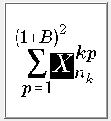
Subscript/Superscript | 11 pt
Sub-Subscript/Superscript | 9 pt
Symbol | 20 pt
Sub-Symbol | 14 pt

Figures. Place the figure as close as possible after the point where it is first referenced in the text. All lines, curves, etc., in figure should be thoroughly explicated.
The caption to the figure should contain the word "Figure", the number of the figure and its title through a dash line "–". All captions on the figure (including the axes captions) should be typed in Times New Roman 12 pt. The symbols in figure are presented in accordance with the requirements for the equation settings. The figure should be centred. Blank line (12 pt) should be left before and after the figure. The drawing inserted in the text of a manuscript should be formatted in JPG. Figures as originals of good quality and well contrasted, are to be in their final form, ready for reproduction. The quality of scanned images is 300 dpi or higher. Text placed at the side of the figure should be set to attach (group) to the figure. If it might be necessary to place a figure within a page turned to 90°, it should be presented as a separate file.
All figures must be presented in the following manner:
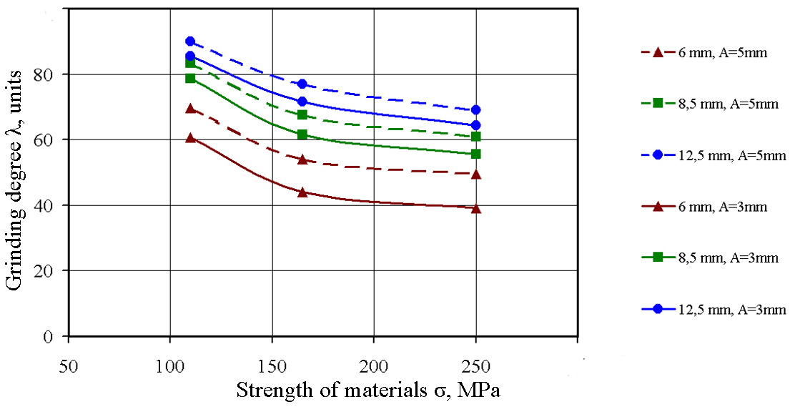

Figure 4 – Graphs of the dependence of the degree of grinding of a material on its strength at different vibration amplitudes

Tables. Place the figure as close as possible after the point where it is first referenced in the text. Tables should have border rules as well as vertical rules. The caption of the table consists of the word "Table", the number of the table and its name through the dash line "–". The caption of the table should be centred, no blank line needed. The caption (number of the table and its name should be typed in Times New Roman 12 pt. The table should be centered. Blank line (12 pt) should be left before and after the table. If it might be necessary to place a figure within a page turned to 90°, it should be presented as a separate file.
All tables must be presented in the following manner:

Table 4 – Distribution of CCW by types for 2000–2001 [32]
Countries | Coal combustion products
Countries | Fly ash |  | Slag |  | Boiler slag |  | Phosphogypsum
Countries | million tons | % | million tons | % | million tons | % | million tons | %
USA | 61.8 | 57.7 | 17.1 | 16 | 2.3 | 2 | 25.9 | 24.2
EU | 38.9 | 66 | 5.6 | 9.5 | 2.4 | 4 | 10.6 | 18

References. The numbers occur within square brackets, like this [1]. The reference list gives the references in numerical, not alphabetical, order. The reference list should be given below the heading "REFERENCES" after the text of a manuscript (the main body of text portion) and separated by a blank line (14 pt). The heading "REFERENCES" should be typed in Arial Narrow, semibold uppercase, 11 pt, centred text. First lines of individual reference should be indented by 7 mm, font Arial Narrow, 10 pt, justified text. Reference should be formatted using "Harvard" referencing style.
Note. The reference list should preferably contain papers published within 5 years.
About the authors. Information about the author(s) should be given after the reference list below the "About the author(s)" heading, separated from references by a blank line (14 pt). "About the authors" heading should be typed in Arial Narrow semibold, 11 pt, centred text. Information about each of the authors should be typed in Arial Narrow, 10 pt, justified text, starting with new line. Last name and First Name of each author should be written as full and complete as possible, semibold italics separated by commas. Further, degree, position, affiliation (please make sure that affiliation is as full and complete as possible, affiliation could be abbreviated in parentheses if needed), city, country, e-mail, ORCID ID should be presented.

Appendix A. Template of a manuscript’s structure

Analysis and ways for advancing of mathematical model of pulverized coal ignition and combustion
¹Petrenko P., ²Sydorenko S.
¹Ukrainian State University of Science and Technologies
²M.S. Poliakov Institute of Geotechnical Mechanics of the National Academy of Sciences of Ukraine

Abstract. An analysis of mathematical models of ignition and burning of a single particle and a coal cloud is given. Models which take into account the presence of ash in particles,…. (should exceed 1800 characters)

Keywords: pulverized coal, combustion, devolatilization, particle, chemical reaction, ignition.

1. Introduction
Pulverized coal combustion is widely used in energy sector since late 19th century. This fact...

References
1. Bezruchko, K.A. (2023), “The impact of moisture content on outburst hazard of sandstones in coal-bearing strata international journal of earth sciences knowledge and applications”, International Journal of Earth Sciences Knowledge and Applications, no. 5(3), pp. 343–350. https://www.ijeska.com/index.php/ijeska/article/view/348/326
2. Zienkiewicz, O.C., Taylor, R.L. and Zhu, J.Z. (2013), The Finite Element Method: Its Basis and Fundamentals, Butterworth-Heinemann, Amsterdam, Netherlands.
3. Krukovska, V.V. and Kocherga, V.M. (2022), “Influence of the method of gate road protection on the operating efficiency of methane drainage boreholes“, IOP Conference Series: Earth and Environmental Science, no. 970, 012045. https://doi.org/10.1088/1755-1315/970/1/012045

About the authors
Petrenko Petro, Candidate of Technical Sciences (Ph.D), Associate Professor, Ukrainian State University of Science and Technologies (USUST), Dnipro, Ukraine, p.petrenko@nas.gov.ua ORCID 0000-YYYY-YYYY-YYYY
Sydorenko Svitlana, Candidate of Technical Sciences (Ph.D), M.S. Poliakov Institute of Geotechnical Mechanics of the National Academy of Sciences of Ukraine (IGTM of the NAS of Ukraine), Dnipro, Ukraine, s.sydorenko@nas.gov.ua ORCID 0000-YYYY-YYYY-YYYY

